INDEX

Introduction--------------------------------------------------------------------------------------------2

**CHAPTER :- 1 INTRODUCTION**----------------------------------------------------------------3

* Background
* Objective
* Purpose
* Scope
* Applicability

**CHAPTER :- 2 REQUREMENT AND ANALYSIS**--------------------------------------------5

* Problem Definition
* Requirement Specification
* Planning and Scheduling
* Developer Requirement

**CHAPTER :- 3 SYSTEM DESIGN**---------------------------------------------------------------8

* System Analysis
* Data Dictionary
* Data Flow Diagram
* E-R Diagram
* Designing

**CHAPTER :- 4 TESTING AND IMPLEMENTATION**---------------------------------------50

* Testing
* Test case

**CHAPTER :- 5 CONCLUSION**------------------------------------------------------------------77

* Limitation of System
* Future Scope of System
* Bibliography

# **INTRODUCTION**

Discover the perfect blend of elegance, tradition, and convenience at Wedding Attire Hire your go-to destination for wedding attire rentals. Step into a world of exquisite fashion, where every outfit tells a unique story and enhances your special moments.

With a carefully curated collection of the latest trends and timeless classics, we offer attire for every wedding occasion, personality, and style. From regal sherwanis and designer lehengas to sophisticated tuxedos and graceful sarees, our diverse range ensures that you look stunning without the hassle of ownership.

At Wedding Attire Hire we believe the right wedding attire can transform not just your appearance but also your confidence. Join us in exploring a world where every ensemble is a statement, and every outfit is a reflection of your unique style.

We take pride in offering a seamless rental experience, exceptional customer service, and premium-quality attire that makes your wedding moments truly unforgettable.

# Chapter - 1 Introduction

##### BACKGROUND

* **Wedding Attire Hire** offers a curated collection of designer wedding outfits for rent. Whether you're searching for elegant bridal wear, groom’s attire, or stylish guest outfits, we’ve got you covered. Step into sophistication and convenience with our premium wedding outfit rental services.
* The rise of **Wedding Attire Hire** is driven by the increasing demand for cost-effective yet stylish wedding fashion, the ease of online shopping, and the expansion of rental fashion trends.
* Our platform provides a seamless experience with a user-friendly interface, detailed outfit descriptions, high-quality images, and customer reviews to help you make the perfect choice.
* We bring you expert reviews and style recommendations to assist you in selecting the ideal wedding attire that suits your preferences and event requirements.
* **Wedding Attire Hire** has revolutionized the way people dress for special occasions, offering a diverse, convenient, and customer-centric rental platform that meets the evolving needs of modern consumers.
* With thousands of outfits available across various categories, our platform ensures that finding the perfect wedding ensemble has never been easier.

##### OBJECTIVE

* The primary objective of Wedding Attire Hire an online wedding attire rental platform, is to provide a seamless, efficient, and enjoyable experience for customers while ensuring affordability and accessibility to premium wedding outfits.
* Our rental service is easy, flexible, and hassle-free, allowing customers to find the perfect wedding attire without the burden of ownership.
* It helps customers save money by offering luxurious outfits at a fraction of the purchase cost, making designer wedding wear more accessible.
* The platform saves time by offering a wide range of wedding attire options in one place, eliminating the need for multiple store visits.
* By reducing intermediaries, we lower overall costs, allowing us to offer high-quality outfits at competitive rental prices.
* Users can explore detailed product specifications, browse multiple high-quality images, and read customer reviews before making a decision. They can also share their own experiences to help future customers.

##### PURPOSE

* The importance of online wedding attire rental is determined by two key factors. The first is understanding customer perception of renting wedding outfits online.
* The second major factor is identifying what influences customers to choose online wedding attire rentals over traditional in-store shopping.
* [Website Name] serves multiple purposes, catering to different wedding styles and preferences by offering a wide range of outfits, from grand bridal lehengas to subtle and elegant reception wear.
* Many people prefer the comfort of selecting their wedding attire from home, avoiding the hassle of store visits and long trials.
* They can browse thousands of options at their own pace without the pressure of a store assistant, making the process stress-free.

##### SCOPE

* The current system can be extended to allow users to create accounts and save wedding outfits to their Wishlist for future rentals.
* Customers can browse and rent wedding attire online anytime, 24/7, through the [Website Name] platform.
* The scope of the website is currently limited to the few city’s, ensuring timely deliveries and seamless rental experiences.

##### APPLICABILITY

* [Website Name] offers a wide range of wedding attire suitable for various occasions, from intimate ceremonies to grand wedding celebrations.
* Our outfits are designed to make the wedding experience more convenient, stylish, and hassle-free.
* Here are some of the most popular wedding attire options we offer:

# Chapter - 2 Requirement and Analysis

##### PROBLEM DEFINITION

* Technology has transformed the way people rent wedding attire. In today’s fast-paced world, customers prefer the convenience of renting outfits online rather than spending hours visiting multiple stores.
* Online wedding attire rental allows people to choose their perfect outfit from the comfort of their homes, saving time and effort.
* It offers a wide range of options and services, but customers may also face some challenges, such as:.
* **Delay in delivery** – Ensuring timely delivery is crucial, especially for wedding events.
* **Missing the in-store experience** – Some customers prefer trying on outfits before making a decision.
* **Online frauds** – Security concerns can arise when renting expensive attire.
* **Spending too much time browsing** – A large selection can sometimes be overwhelming.
* **Less personal interaction** – The lack of direct contact with designers or stylists.
* **Complicated return policies** – Some rental services may have strict terms.
* **Limited support for local retailers** – Online rentals can impact traditional wedding attire store

##### REQURIMENT SPECIFICATION

• This section defines the complete set of functional and non-functional requirements identified for this wedding attire rental website.

* **Functional:**

Functional requirements are which provides customer to register, like they can maintain the record of the products that the customer want to purchase later i.e the website is able to maintain a list of choiced products selected by the registered customer.

* **Non-Functional:**

Non-functional requirements are mostly quality-related requirements which include the area of performance, availability, reliability, usability, flexibility, configurability, integration, maintainability, portability, and testability.

##### PLANNING AND SCHEDULING

##### DEVELOPER REQUIREMENT

* **Software Requirement:**
* **Browser:** Chrome
* **Operating System:** Compatible with all major Operating systems
* **Frontend:** PHP 8.3
* **Backend:** MySQL 8.0
* **Software:** XAMPP 8.2.12
* **Design:** HTML-5, JavaScript, CSS
* **Hardware Requirement:** 
  + **Processor:** Compatible with all Intel Core processors
  + **RAM:** 2 GB or above
  + **Hard Disk:** 10 GB

# Chapter - 3 System Design

##### SYSTEM ANALYSIS

System analysis involves gathering and interpreting facts, diagnosing problems, and recommending improvements. It is a crucial phase in system development, requiring close communication between users and developers. The entire system is examined, inputs are identified, and potential issues are analyzed. Proposed solutions are reviewed, modified as needed, and finalized based on user satisfaction.

##### Existing System

The traditional process of renting wedding attire requires customers to visit physical stores, browse through available outfits, and complete the rental process in person.

**Limitations of the Existing System:**

* **Less user-friendly** – Requires physical store visits.
* **Time-consuming** – Customers must search through various stores.
* **Limited accessibility** – Distant users cannot easily rent outfits.
* **Product descriptions are minimal** – Customers rely on verbal explanations.
* **Difficult to compare options** – Limited access to outfit reviews and recommendations.

##### Proposed System

The proposed system allows customers to rent wedding attire online, eliminating the need for in-store visits. Users can browse and order their preferred outfits from a mobile-friendly website, making the process seamless and efficient.

##### System Tools

* 1. **PHP:**

The term PHP is an acronym for PHP: Hypertext Pre-processor. PHP is a server-side scripting language designed specifically for web development.

PHP can actually do anything related to server-side scripting or more popularly known as the backend of a website.

For example, PHP can receive data from forms, generate dynamic page content, can work with databases, create sessions, send and receive cookies, send emails etc.

There are also many hash functions available in PHP to encrypt user’s data that makes PHP secure and reliable to be used as a server-side scripting language. So these are some of the abilities of PHP that makes it suitable to be used as server-side scripting language.

**1.2) MySQL:**

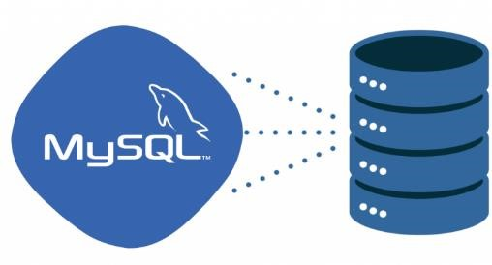

MySQL is an open-source relational database management system (RDBMS). It is the most popular database system used with PHP. MySQL is developed, distributed, and supported by Oracle Corporation.

The data in a MySQL database are stored in tables which consists of columns and rows.

* + - MySQL is a database system that runs on a server.
    - MySQL is ideal for both small and large applications.
    - MySQL is very fast, reliable and easy to use database system. It uses standard SQL
    - MySQL compiles on a number of platforms.

**1.3) XAMPP:**

XAMPP is a cross-platform web server that is free andopen-source.

XAMPP is a short form for Cross-Platform, Apache, MySQL, PHP, and Perl.

XAMPP is a popular cross-platform web server that allows programmers to write and test their code on a local webserver.

It was created by Apache Friends, and the public can revise or modify its native source code.

It includes MariaDB, Apache HTTP Server, and interpreters for PHP and Perl, among other computer languages.

Because of XAMPP’s simplicity of deployment, a developer can quickly and easily install a WAMP or LAMP stack on an operating system, with the added benefit that common add-in apps like WordPress and Joomla can also be loaded.

**1.4) HTML:**

 HTML for Hyper Text Markup Language. It is used to design web pages using markup language.

HTML is the combination of Hypertext and Markup language.

Hypertext defines the link between the web pages. Markup language is used to definethe text document within tag which defines the structure of web pages. This language is used to annotate (make notes for the computer) text so that a machine can understand it and manipulate text accordingly.

Most markup languages (e.g. HTML) are human readable. Language uses tags to define

what manipulation has to be done on the text.HTML is a Markup language used by the browser to manipulate text, images and other content, in order to display it in the required format.

HTML uses predefined tags and elements which tell the browser how to properly display the content. Remember to include closing tags. If omitted, the browser applies the effect of the opening tag until the end of page. Attribute tell us more about elements.

Attribute provide additional information about the contents of an elements. They appear on the opening tag of the element and are made up of two parts: a name and a value, separated by an equals sign.

**1.5) Cascading Style System (CSS):**

Cascading Style Sheets, fondly referred to as CSS, is a simply designed language intended to simplify the process of making web pages presentable. CSS allows you to apply styles to web pages. More importantly, CSS enables you to do this independent of the HTML that makes up each web page. CSS is easy to learn and understood but it provides powerful control over the presentation of an HTML document.

**1.6) JAVASCRIPT:**

JavaScript is a very powerful client-side scripting language. JavaScript is used mainly for enhancing the interaction of a user with the webpage. In other words, you can make your webpage more lively and interactive, with the help of JavaScript. JavaScript is also being used widely in game development and Mobile application development**.**

##### DATA DICTIONARY

A data dictionary is a file that helps to define the organization of a particular database. The data dictionary acts as a description of the data objects or items in a model and is used for the benefit of the programmer or other people who may need to access it.

A data dictionary does not contain the actual data from the database; it contains only information for how to describe/manage the data; this is called metadata*. Building a data dictionary provides the ability to know the kind of field, where it is located in a database, what it means, etc. It typically consists of a table with multiple columns that describe relationships as well as labels for data.

**A data dictionary often contains the following information about fields:**

* Default values
* Constraint information
* Definitions (example: functions, sequence, etc.)
* The amount of space allocated for the object/field
* Auditing information

**What is the data dictionary used for?**

1. It can also be used as a read-only reference in order to obtain information about the database.
2. A data dictionary can be of use when developing programs that use a data model.
3. The data dictionary acts as a way to describe data in “real-world” terms.

**Why is a data dictionary needed?**

One of the main reasons a data dictionary is necessary is to provide better accuracy, organization, and reliability in regards to data management and user/administrator understanding and training.

**Benefits of using a data dictionary:**

* 1. Improved data quality
  2. Consistency in data use
  3. Improved documentation and control of data
  4. Faster and easier data analysis
  5. Easier Programming
  6. Better trust in data integrity
  7. Increased efficiency

1. **Table Name :** Admin_users

**Table Description:** Table for admin login details

|  |  |  |  |  |  |
| --- | --- | --- | --- | --- | --- |
| **Sr No.** | **Field Name** | **Data Type** | **Size** | **Constraint** | **Description** |
| 1. | id | int | 11 | Primary Key | Admin id,  Auto Increment |
| 2. | username | text | - | Not Null | Name of Admin |
| 3. | password | varchar | 50 | Not Null | Password of Admin |
| 4. | role | int | 11 | Not Null | Role of Admin &  Agent |
| 5. | email | varchar | 50 | Not Null | Email of Admin &  Agent |
| 6. | mobile | Varchar | 50 | Not Null | Mobile no of Admin  & Agent |
| 7. | status | int | 11 | Not Null | Shows Status |

1. **Table Name :** Users

**Table Description :** Table for users details.

|  |  |  |  |  |  |
| --- | --- | --- | --- | --- | --- |
| **Sr No.** | **Field Name** | **Data Type** | **Size** | **Constraint** | **Description** |
| 1. | id | int | 11 | Primary Key | User id,  Auto Increment |
| 2. | name | text | - | Not Null | User name |
| 3. | password | varchar | 50 | Not Null | User Password |
| 4. | email | varchar | 50 | Not Null | User Email |
| 5. | mobile | varchar | 15 | Not Null | User Mobile No |
| 6. | added_on | datetime | - | Not Null | Store Date and Time |

1. **Table Name :** Categories

**Table Description :** Table for categories details.

|  |  |  |  |  |  |
| --- | --- | --- | --- | --- | --- |
| **Sr No.** | **Field Name** | **Data Type** | **Size** | **Constraint** | **Description** |
| 1. | id | int | 11 | Primary Key | Categories id,  Auto Increment |
| 2. | categories | varchar | 255 | Not Null | Categories Name |
| 3. | status | tinyint | 4 | Not Null | Categories Status |

1. **Table Name:** Sub-categories

**Table Description:** Table for sub categories details.

|  |  |  |  |  |  |
| --- | --- | --- | --- | --- | --- |
| **Sr No.** | **Field Name** | **Data Type** | **Size** | **Constraint** | **Description** |
| 1. | id | int | 11 | Primary Key | Sub_categories id, Auto Increment |
| 2. | Categories_id | int | 11 | Foreign Key | Store Categories id |
| 3. | Sub_categories | varchar | 100 | Not Null | A secondary categories |
| 4. | status | int | 11 | Not null | Store categories status |

1. **Table Name :** Product

**Table Description :** Table for product details.

|  |  |  |  |  |  |
| --- | --- | --- | --- | --- | --- |
| **Sr No.** | **Field Name** | **Data Type** | **Size** | **Constraint** | **Description** |
| 1. | id | int | 11 | Primary Key | Product id,  Auto Increment |
| 2. | categories_id | int | 11 | Foreign Key | Store Categories id |
| 3. | sub_categories _id | int | 11 | Foreign Key | Store sub categories id |
| 4. | name | text | - | Not Null | Product name |
| 5. | image | varchar | 255 | Not Null | Product image |
| 6. | short_desc | text | - | Not Null | Product short description |
| 7. | description | text | - | Not Null | Product description |
| 8. | meta_title | varchar | 255 | Not Null | Product meta title |
| 9. | meta_desc | varchar | 255 | Not Null | Product meta description |
| 10. | meta_keyword | varchar | 255 | Not Null | Product meta  keyword |
| 11. | added_by | int | 11 | Not Null | It will allow to product |
| 12. | status | tinyint | 4 | Not Null | Product status |

**6.Table Name :** Order

**Table Description :** Table for order details.

|  |  |  |  |  |  |
| --- | --- | --- | --- | --- | --- |
| **Sr No.** | **Field Name** | **Data Type** | **Size** | **Constraint** | **Description** |
| 1. | id | int | 11 | Primary Key | Order id,  Auto Increment |
| 2. | user_id | int | 11 | Foreign Key | Store user id |
| 3. | address | varchar | 250 | Not Null | Store user address |
| 4. | city | varchar | 50 | Not Null | Store user city |
| 5. | pincode | int | 11 | Not Null | Store user pin code |
| 6. | payment_type | varchar | 20 | Not Null | Show payment  type |
| 7. | total_price | float | - | Not Null | Product total price |
| 8. | payment_status | varchar | 20 | Not Null | Show payment status |
| 9. | order_status | int | 11 | Not Null | Show Order status |
| 10. | txnid | varchar | 200 | Not Null | Show Tocken id |
| 11. | mihpayid | varchar | 200 | Not Null | Show Online  Payment info.. |
| 12. | ship_order_id | int | 11 | Not Null | Show Ship Order  id |
| 13. | Ship_shipment_id | int | 11 | Not Nul | Show Shipment id |
| 14. | Payu_status | varchar | 10 | Not Null | Show Status of payment |
| 15. | coupon_id | int | 11 | Not Null | Store Coupon id |
| 16. | coupon_value | varchar | 50 | Not Null | Store coupon  value |
| 17. | coupon_code | varchar | 50 | Not Null | Store coupon  code |
| 18. | added_on | datetime | - | Not Null | Show Date and Time |

1. **Table Name :** Order_detail

**Table Description :** Table for order brief details

|  |  |  |  |  |  |
| --- | --- | --- | --- | --- | --- |
| **Sr No.** | **Field Name** | **Data Type** | **Size** | **Constraint** | **Description** |
| 1. | id | int | 11 | Primary Key | Order_detail id, Auto Increment |
| 2. | order_id | varchar | 255 | Foreign Key | Store Order id |
| 3. | product_id | varchar | 50 | Foreign Key | Store product id |
| 4. | product_attr_id | int | 11 | Not Null | Store Attribute id |
| 4. | qty | int | 11 | Not Null | Store product  quantity |
| 5. | price | float | - | Not Null | Store price of product |
| 6 | Rent_from | date | - | Not Null | Store the date of rent from |
| 7 | Rent_to | date | - | Not Null | Store the date of rent to |

1. **Table Name :** Order_status

**Table Description :** Table for order status details.

|  |  |  |  |  |  |
| --- | --- | --- | --- | --- | --- |
| **Sr No.** | **Field Name** | **Data Type** | **Size** | **Constraint** | **Description** |
| 1. | id | int | 11 | Primary Key | Order status id, Auto Increment |
| 2. | name | varchar | 32 | Not Null | Stores order status name |

1. **Table Name :** Contact_us

**Table Description :** Table for contact_us details.

|  |  |  |  |  |  |
| --- | --- | --- | --- | --- | --- |
| **Sr No.** | **Field Name** | **Data Type** | **Size** | **Constraint** | **Description** |
| 1. | id | int | 11 | Primary Key | Contact_us id,  Auto Increment |
| 2. | name | text | - | Not Null | Name of user |
| 3. | email | varchar | 75 | Not Null | Email of user |
| 4. | mobile | varchar | 15 | Not Null | Mobile no of user |
| 5. | comment | text | - | Not Null | Message for  contact User to admin |
| 6. | added_on | datetime | - | Not Null | Show Date and  Time |

1. **Table Name :** Wishlist

**Table Description :** Table for wishlist details.

|  |  |  |  |  |  |
| --- | --- | --- | --- | --- | --- |
| **Sr No.** | **Field Name** | **Data Type** | **Size** | **Constraint** | **Description** |
| 1. | id | int | 11 | Primary Key | Wishlist id, Auto Increment |
| 2. | user_id | int | 11 | Foreign Key | Store user id |
| 3. | product_id | int | 11 | Foreign Key | Store product id |
| 4. | added_on | datetime | - | Not null | Show Date and Time |

1. **Table Name :** Product_attributes

**Table Description :** Table for product attributes details.

|  |  |  |  |  |  |
| --- | --- | --- | --- | --- | --- |
| **Sr No.** | **Field Name** | **Data Type** | **Size** | **Constraint** | **Description** |
| 1. | id | int | 11 | Primary Key | Product_attributes id, Auto Increment |
| 2. | product_id | int | 11 | Foreign Key | Show product id |
| **3.** | size_id | int | 11 | Not Null | Show Size id |
| 3. | color_id | int | 11 | Not Null | Store color id |
| 4. | mrp | int | 11 | Not Null | Product mrp |
| 5. | price | int | 11 | Not Null | Product price |
| 6. | qty | int | 11 | Not Null | Product quantity |

**12. Table Name :** Product_images

**Table Description :** Table for product images details

|  |  |  |  |  |  |
| --- | --- | --- | --- | --- | --- |
| **Sr No.** | **Field Name** | **Data Type** | **Size** | **Constraint** | **Description** |
| 1. | id | int | 11 | Primary Key | Store id, Auto  Increment |
| 2. | product_id | int | 11 | Not Null | Store Product id |
| 3. | product_image | varchar | 255 | Not Null | Show Product  image |

1. **Table Name :** Product_review

**Table Description :** Table for product review details

|  |  |  |  |  |  |
| --- | --- | --- | --- | --- | --- |
| **Sr No.** | **Field Name** | **Data Type** | **Size** | **Constraint** | **Description** |
| 1. | id | int | 11 | Primary Key | Product_review id, Auto Increment |
| 2. | product_id | int | 11 | Not Null | Store product id |
| 3. | user_id | int | 11 | Not Null | Store user id |
| 4. | rating | varchar | 20 | Not Null | Product rating |
| 5. | review | text | - | Not Null | Product review |
| 6. | status | int | 11 | Not Null | Show product  status |
| 7. | added_on | datetime | - | Not Null | Show Date and  Time |

**14. Table Name :** Size_master

**Table Description :** Table for product size details

|  |  |  |  |  |  |
| --- | --- | --- | --- | --- | --- |
| **Sr No.** | **Field Name** | **Data Type** | **Size** | **Constraint** | **Description** |
| 1. | id | int | 11 | Primary Key | Size id, Auto  Increment |
| 2. | size | varchar | 255 | Not Null | Size name |
| 3. | status | tinyint | 4 | Not Null | Show product  size status |
| 4. | order_by | int | 11 | Not null | Show product  order |

**14. Table Name :** color_master

**Table Description :** Table for product color details

|  |  |  |  |  |  |
| --- | --- | --- | --- | --- | --- |
| **Sr No.** | **Field Name** | **Data Type** | **Size** | **Constraint** | **Description** |
| 1. | id | int | 11 | Primary Key | color id, Auto  Increment |
| 2. | color | varchar | 255 | Not Null | color _code |
| 3. | status | tinyint | 4 | Not Null | Show product  Color status |
| 4. | order_by | int | 11 | Not null | Show product  order 1or 0 |
| 5. | Color_name | varchar | 255 | Not Null | color name |

**15. Table Name :**  **coupon** _master

**Table Description :** Table for **coupon** details

|  |  |  |  |  |  |
| --- | --- | --- | --- | --- | --- |
| **Sr No.** | **Field Name** | **Data Type** | **Size** | **Constraint** | **Description** |
| 1. | id | int | 11 | Primary Key | **coupon** id, Auto Increment |
| 2. | **coupon_code** | varchar | 255 | Not Null | Store **coupon code** |
| 3. | **coupon_value** | int | 11 | Not Null | Store **coupon value** |
| 4. | **coupon_type** | varchar | 255 | Not Null | Store **coupon type** |
| 4. | **cart_min_value** | int | 11 | Not Null | Store **cart_min_value** |
| 5. | **status** | int | 11 | Not Null | Store **status** |

##### DATA FLOW DIAGRAM

DFD graphically representing the functions, or processes, which capture, manipulate, store, and distribute data between a system and its environment and between components of a system. The visual representation makes it a good communication tool between User and System designer. Structure of DFD allows starting from a broad overview and expand it to a hierarchy of detailed diagrams.

**DFD has often been used due to the following reasons:**

* Logical information flow of the system
* Determination of physical system construction requirements
* Simplicity of notation
* Establishment of manual and automated systems requirements **Notations:**
* **Symbols used in DFD :** 
  1. **Process:** 
     + A process shows transformation or manipulation of data flow within the system. The symbol used in an oval shape.
  2. **External Entity:** 
     + An external entity is source or destination of data flow. Only those entities which originate or receive data represented on data flow diagram. The symbol used is a rectangular box.
  3. **Data Flow:** 
     + A data flow shows the flow of information from a source to its destination. Dataflow is represented by a line, with arrowheads showing the direction of flow. Information always flows to or from a process and may be written, verbal or electronic.
  4. **Data Store:** 
     + A data store is a holding place for information within system. It is represented by an open-ended narrow rectangle. Data store may be long-term file such as sales ledgers, or may be short-term accumulations.

**Context Level DFD**

The context level data flow diagram (dfd) is describe the whole system. The (o) level dfd describe the all user module who operate the system. Below data flow diagram of online shopping site shows the two user can operate the system Admin and Member user.

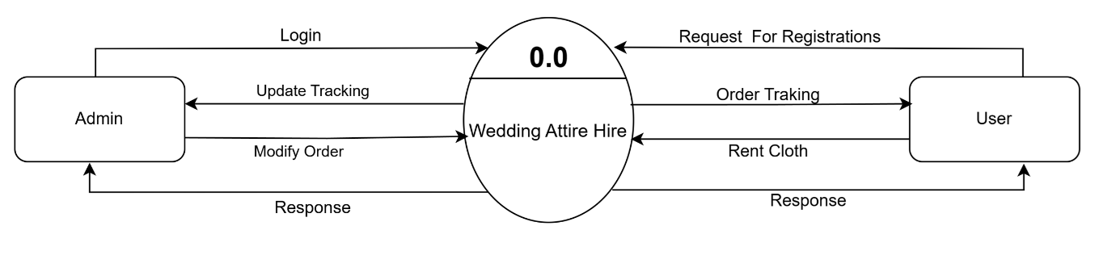

**Figure: Context Level DFD**

**1st Level Admin Side DFD**

The Admin side DFD describe the functionality of Admin, Admin is a owner of the website. Admin can first add category of item and then add items by category wise. and admin can manage order and payment detail.

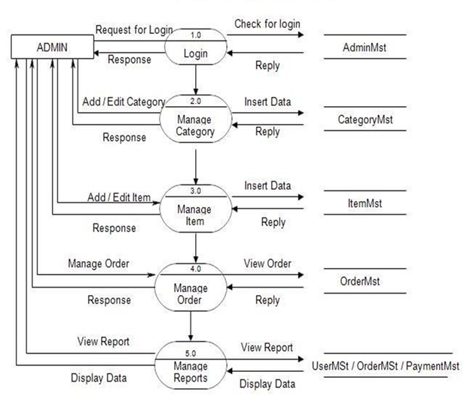

**Figure: 1st Level Admin Side DFD**

**2nd Level DFD for Admin Side (3.0)**

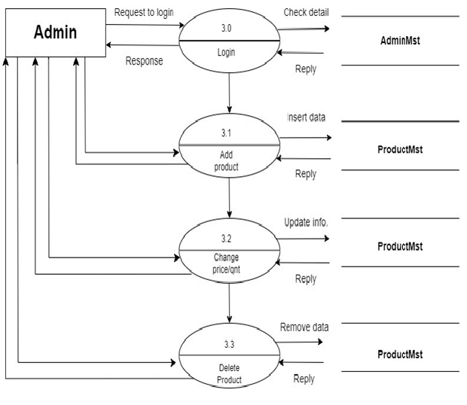

**Figure:**  **2nd Level DFD for Admin Side (3.0)**

**2nd Level for Admin Side (4.0)**

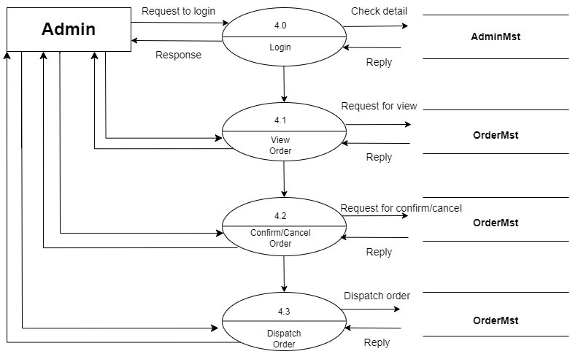

**Figure:**  **2nd Level DFD for Admin Side (4.0)**

**2nd Level for Admin Side (5.0)**

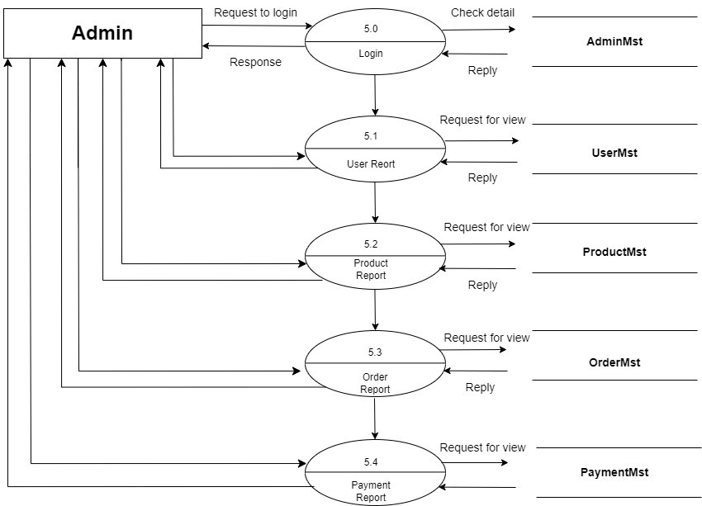

**Figure:**  **2nd Level DFD for Admin Side (5.0)**

**1St Level User Side DED**

The user is all people who operate or visit our website. User is a customer of a website. User can first select product for buy, user must have to register in our system for purchase any item from our website. after register he can login to site and buy item by making online payment through any bank debit card or credit card.

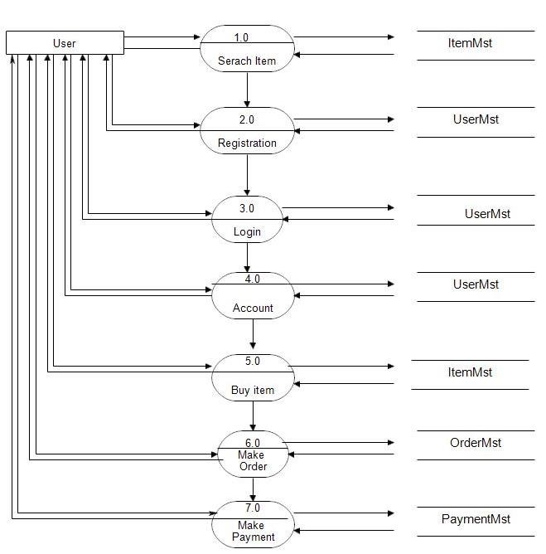

**Figure :** **1St Level User Side DED**

**2nd Level for User Side (4.0)**

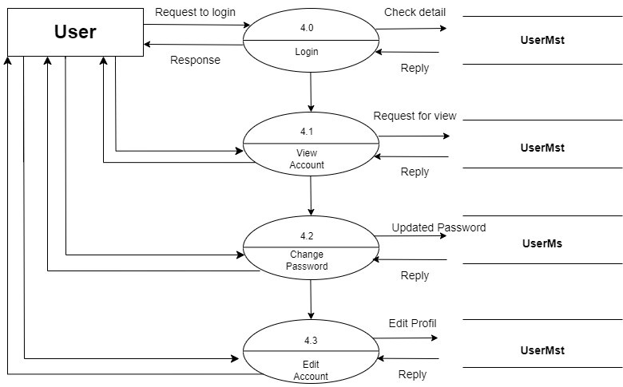

**Figure : 2nd Level for User Side (4.0)**

**2nd Level for User Side (5.0)**

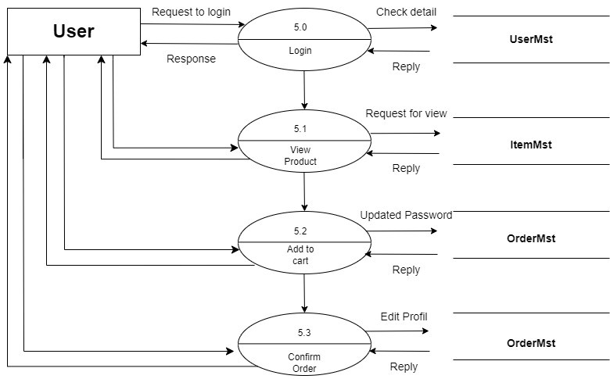

**Figure : 2nd Level for User Side (5.0)**

##### Entity Relationship Diagram (ERD)

An entity relationship diagram is a visual representation of different data using conventions that describe how these data are related to each other. While able to describe just about any system, ER-diagram are most often associated in engineering software’s and if networks.

ER-diagram are frequently used the design stage of a development process in order to identify different system element and their relationship with each other.

**Types of ERD**

ER diagrams will differ on how they express cardinality. They will also differ in how they display entities and their attributes and whether or not they show relationships or attributes as separate symbols.

1. Traditional ERD
2. IDEF1X Notation ERD - Relational Schema

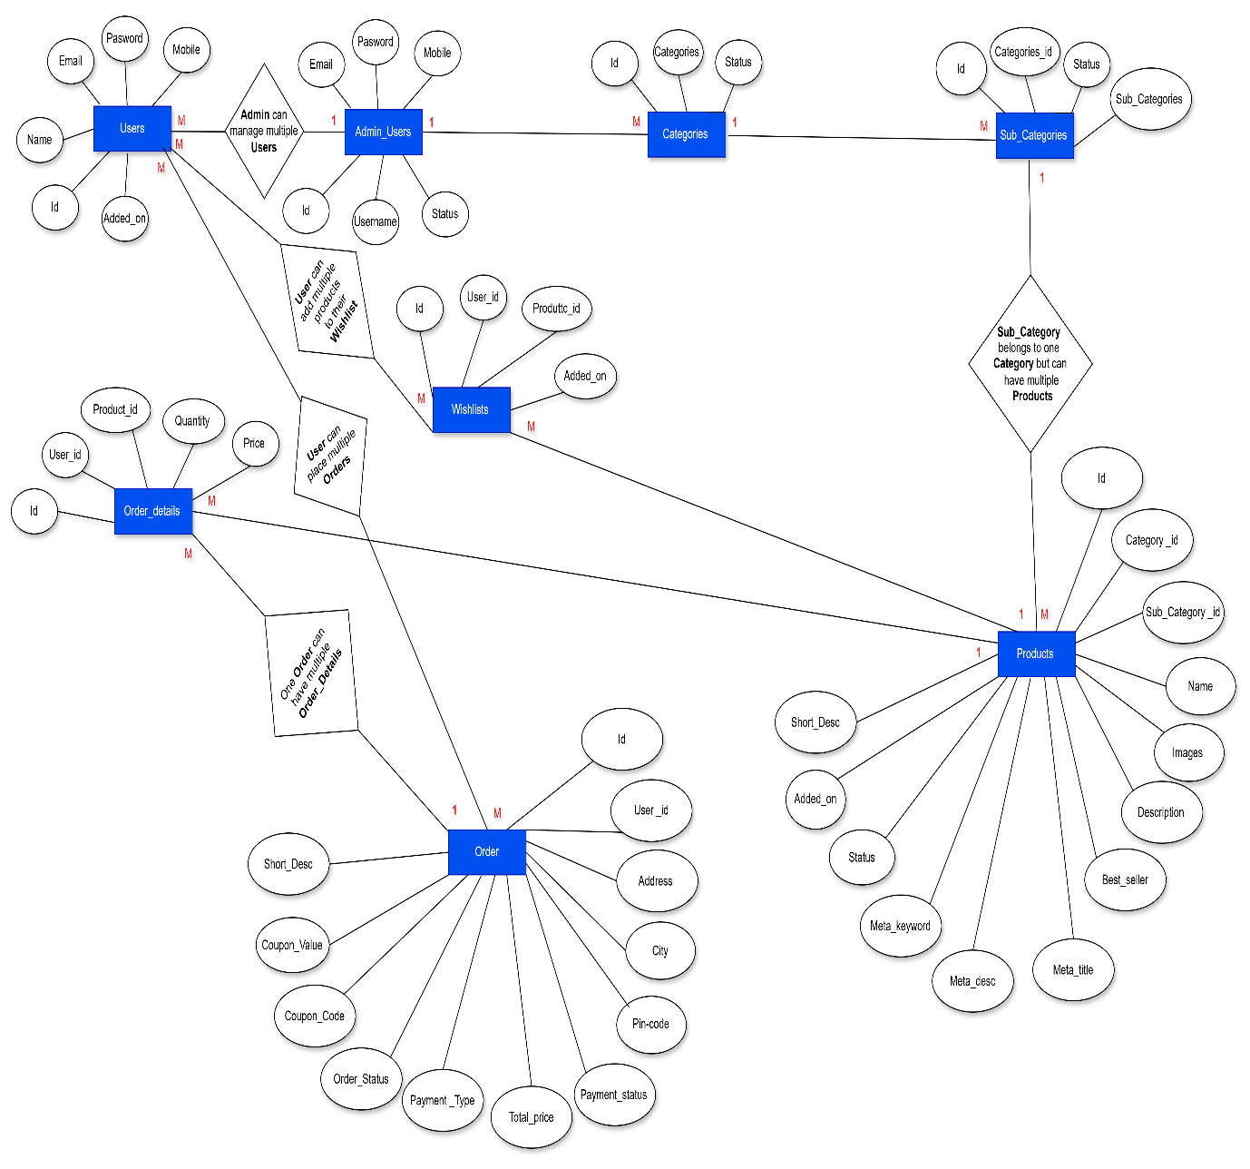

##### DESIGNING

**Login Page**

* This is login page of both admin and agent.
* If username and password belongs to admin then it will redirect admin panel otherwise it will redirect agent panel based on their role.

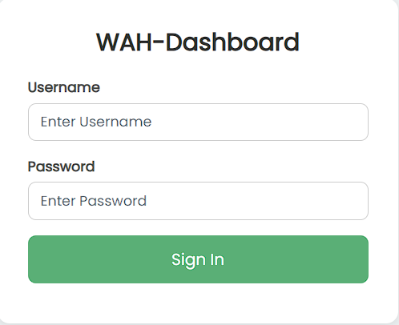

**Categories Page**

* This is the dashboard of admin where admin can manage and modify categories.
* Admin can add new categories into the existing system with all its details.
* Admin can delete the categories based on the stock of that particular product.

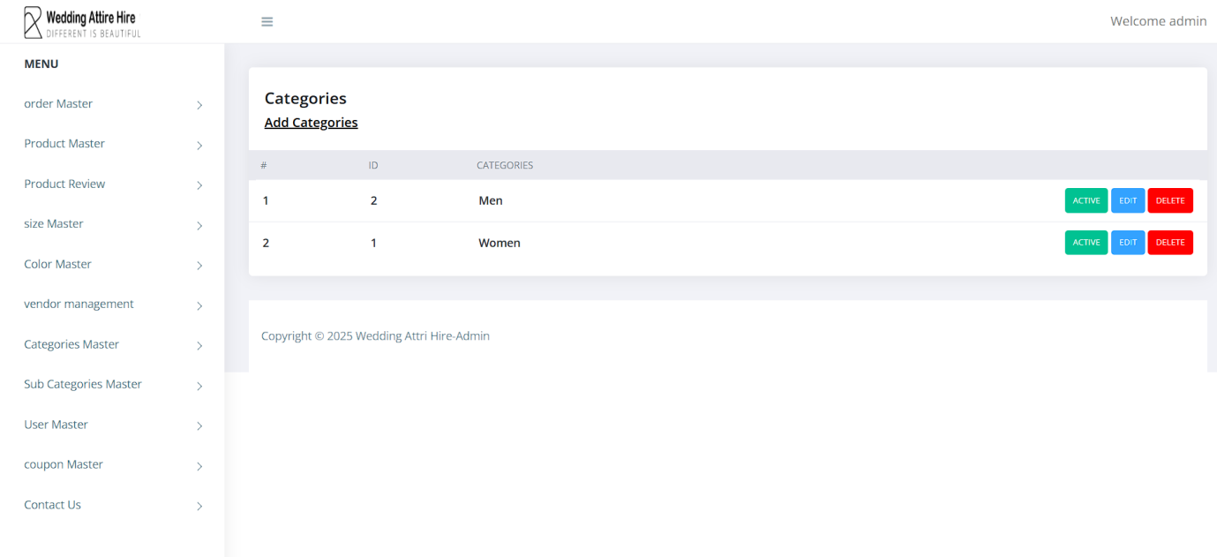

**Sub Categories Page**

* This is the dashboard of admin where admin can manage and modify Sub categories**.**
* This is page where sub categories are listed.
* This categories can be classified into different sub categories by name.

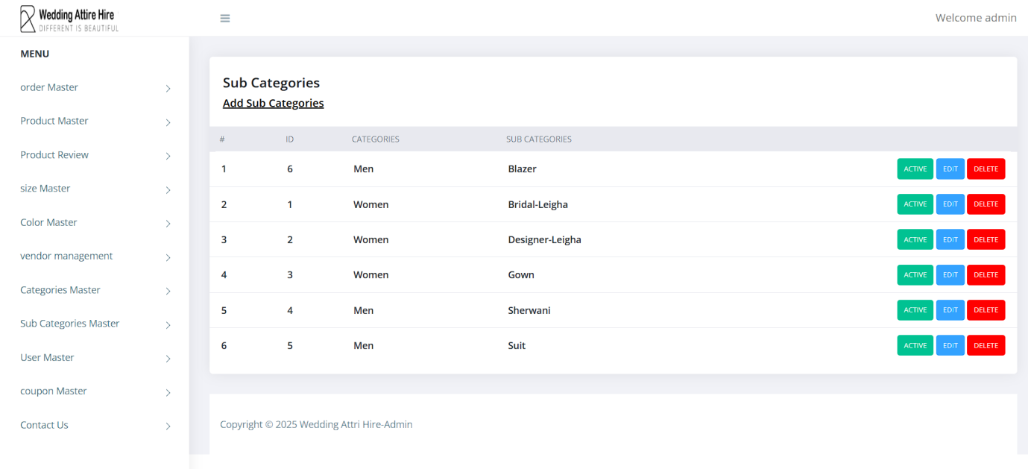

**Products Page**

* This is the page where the products are listed and also being managed.
* This product can be classified into different categories by name.
* Admin can add new products into the existing system with all its details including an image.
* Admin can delete the products based on the stock of that particular product

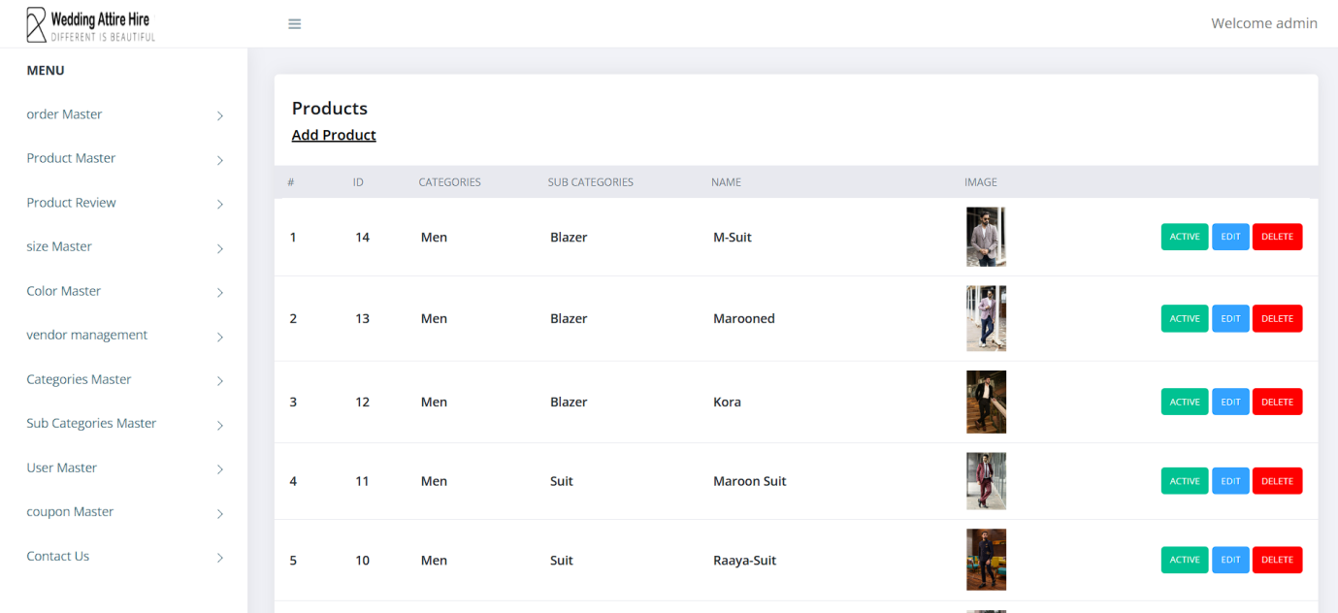

**Size Page**

* This is the page where product size are listed.
* Admin can add new products size into the existing system with all its details including an image.
* Admin can delete the products size based on the stock of that particular product size.

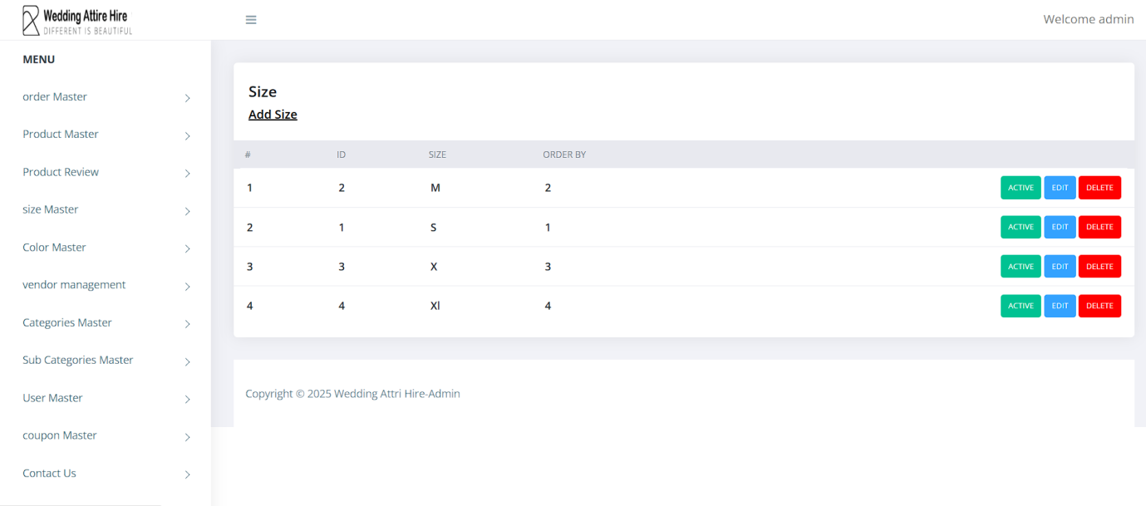  
**Color Page**

* This is the page where product Color are listed.
* Admin can add new products Color into the existing system with all its details including an image.

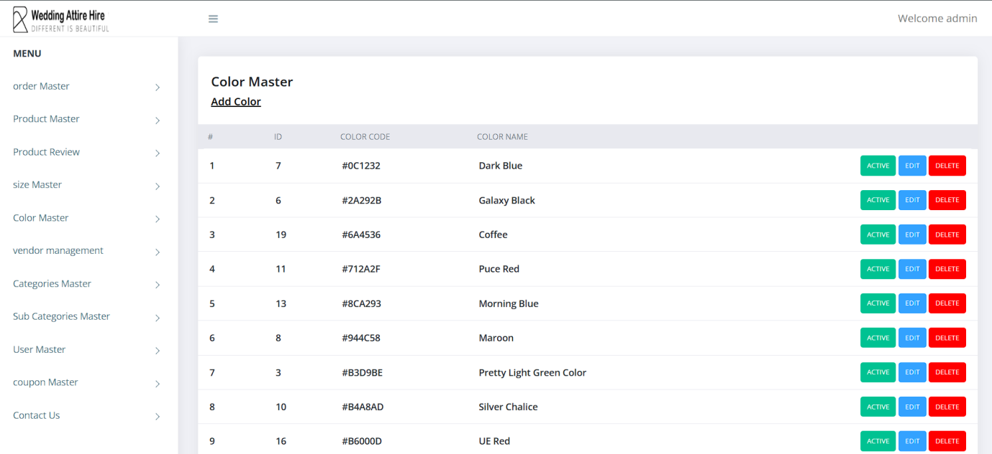

**Users Page**

* This is the page where the user are listed.
* The admin will have a list view of all users registered in the system.
* Admin can view all the details of each user in the list except password.
* Admin has right to delete a user.

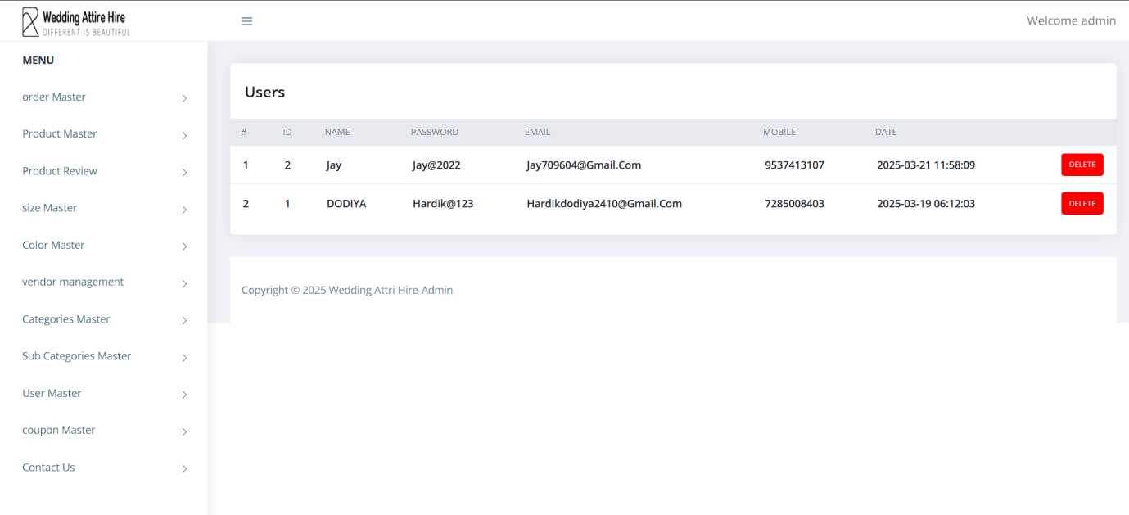

**Contact Us Page**

* This is the contact us page where user can communicates with admin and solve their query about our product.

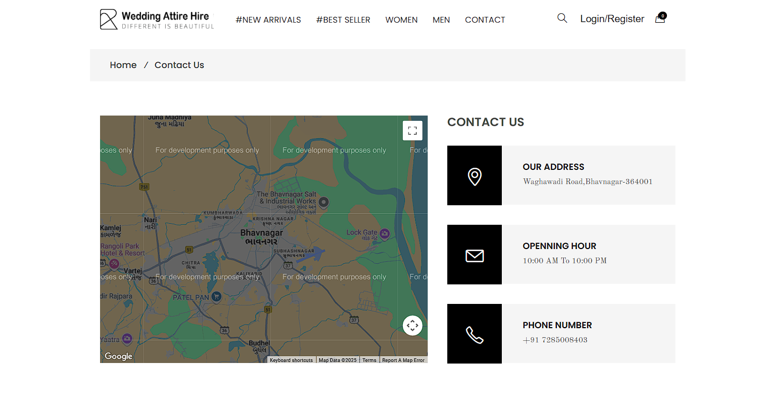

**Home Page**

* This is the main page of our system here, user can view home page, contact us page, search option, login and register page, cart button.
* User will have a list of products. So user can also search for a particular product by name .

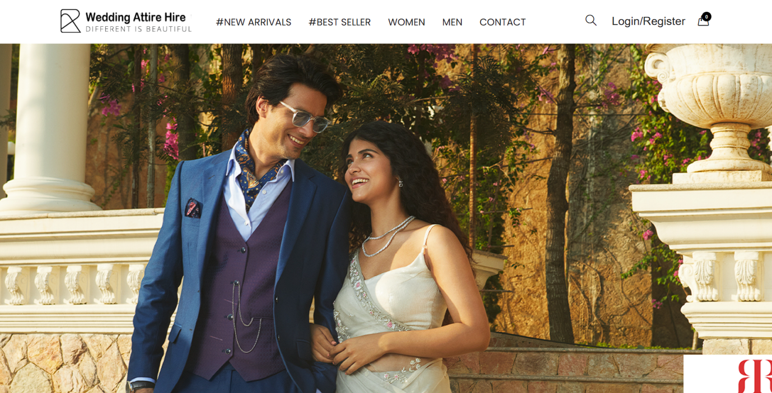

**New Arrivals**

* This page the product which has newly launched in our website.

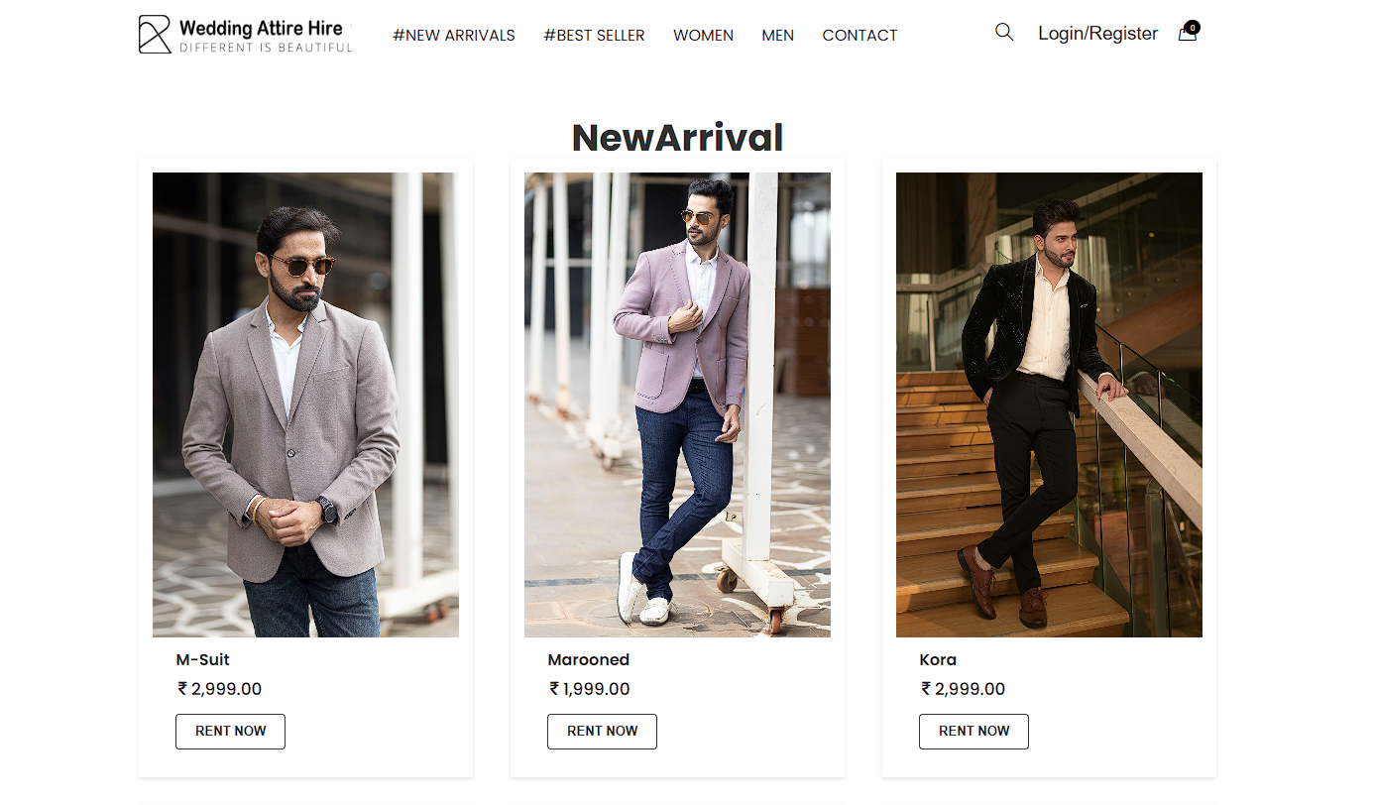

**Best Rental Page**

* Best Rentals offers top-quality, affordable, and reliable rental services for a seamless experience.

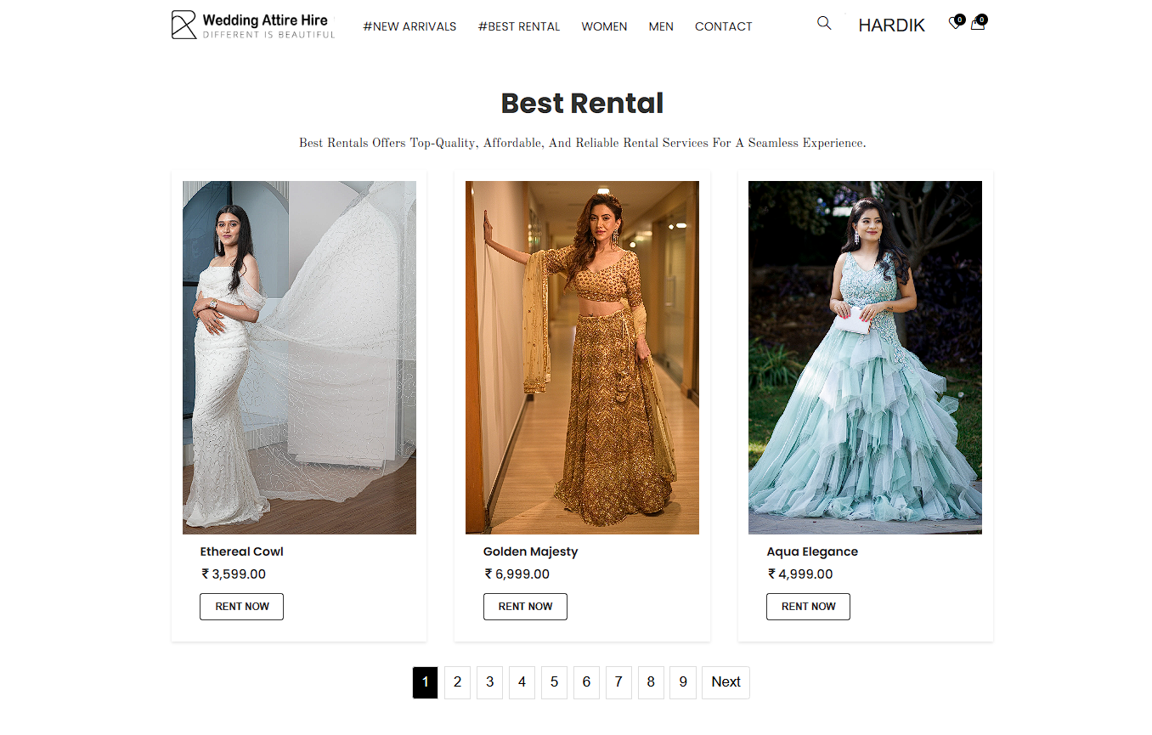

**Categories Page**

* This is page where sub categories are listed.
* This categories can be classified into different sub categories by name.

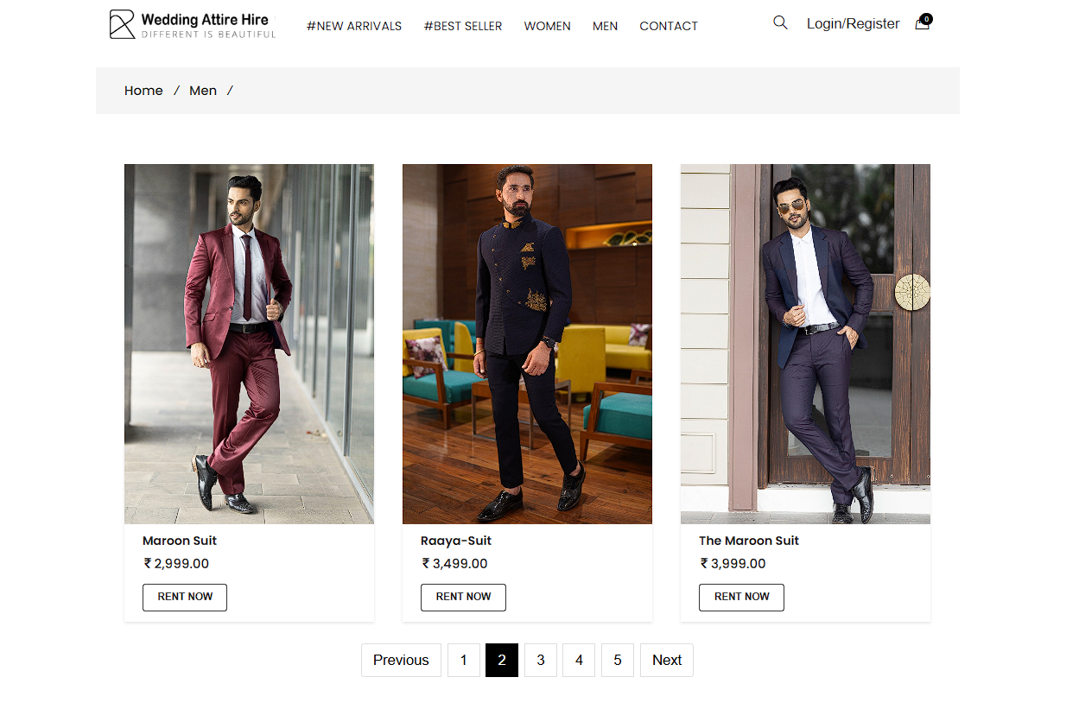

**Product Page**

* A user can view complete description of the product by clicking on the product link.
* User can view the list of products based on their names after successful login. A detailed description of a particular product with product name, products details, product image, price can be viewed by the users.

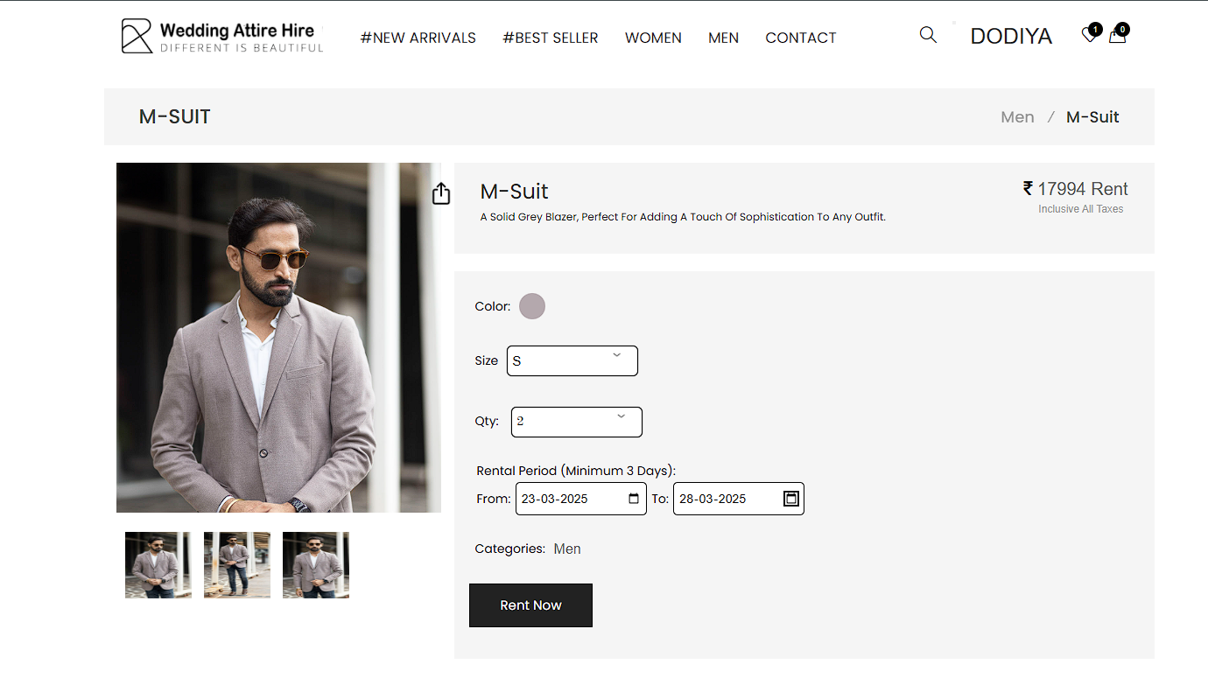

**Wishlist Page**

* A wishlist allows shoppers to create personalized collections of product they want to buy and save them in their user account for future reference.
* Whislist signify a customer interest in a product without any intermediate intent to purchase.

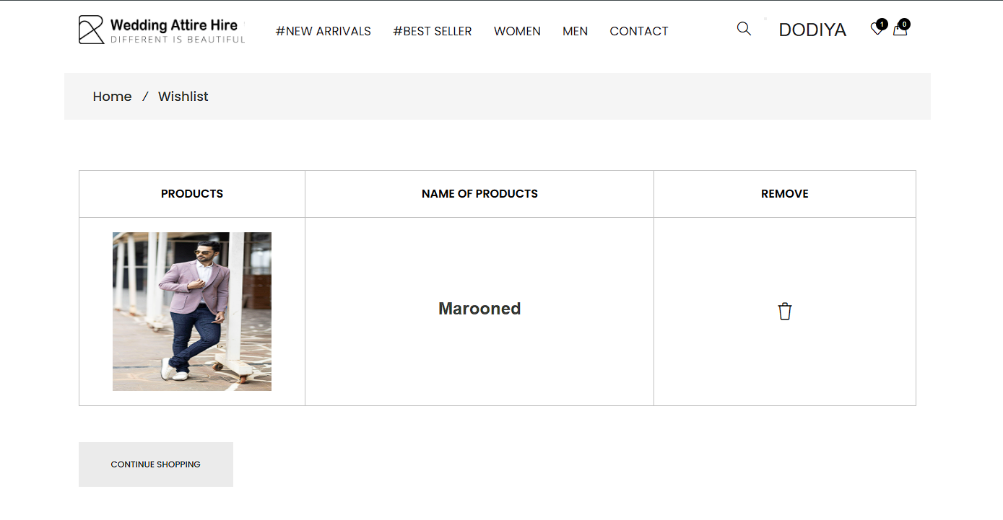

**Shopping Cart Page**

* The user can add the desired product into his cart by clicking add to cart option on the product**.**
* The user can click on the go to cart button to see the items in the cart as shown in figure.
* He can view his cart by clicking on the cart button. All products added by cart can be viewed in the cart. User can remove an item from the cart by clicking remove button.
* Here user can see Product Image, Name of the Product, Price, Quantity, Total price and Remove
* button.
* After confirming the items in the cart the user can submit the cart by providing a delivery address. On successful submitting the cart will become empty.

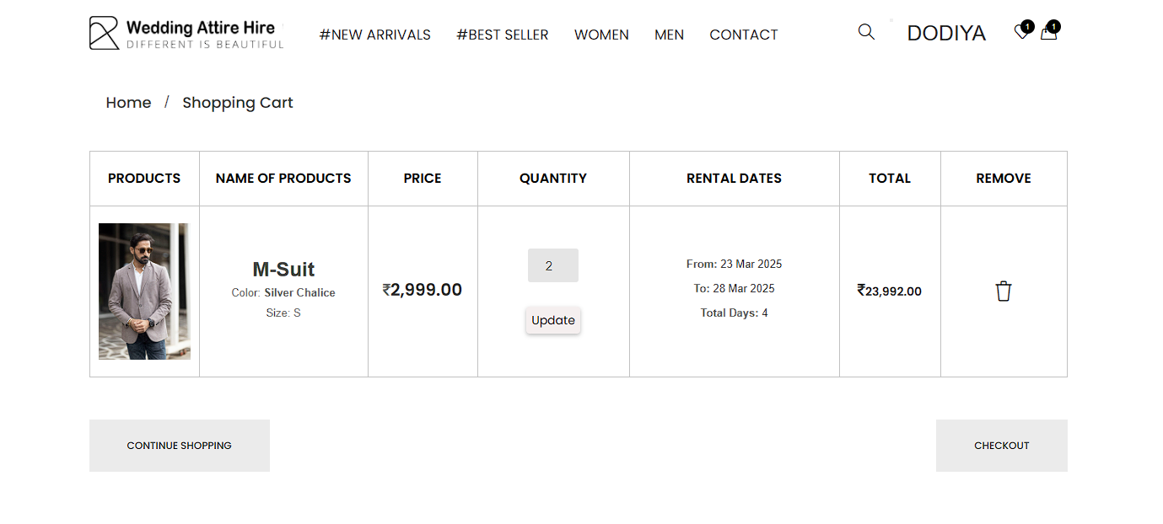

**Checkout Page**

* A checkout page is the page related to payment and shipping/billing details.
* The checkout page gives customer the opportunity to enter payment details and complete their order.
* The checkout process will collect the information about the customer shipping details and billing details.

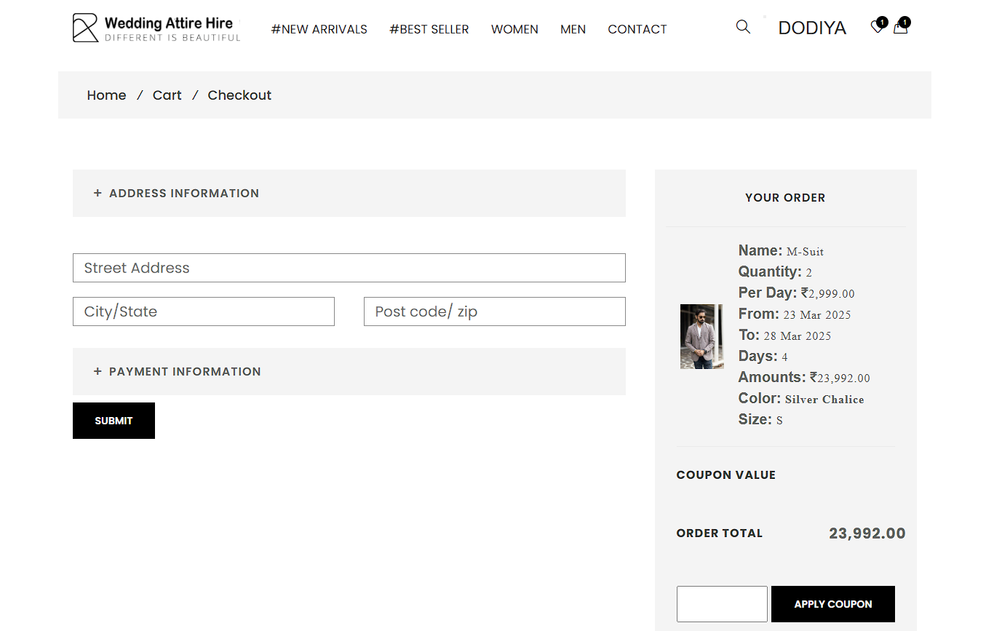

**User Order**

* This page displays information about **new or pending rental orders**.
* It includes details about the **rented outfits** as well as the **customer's information**.

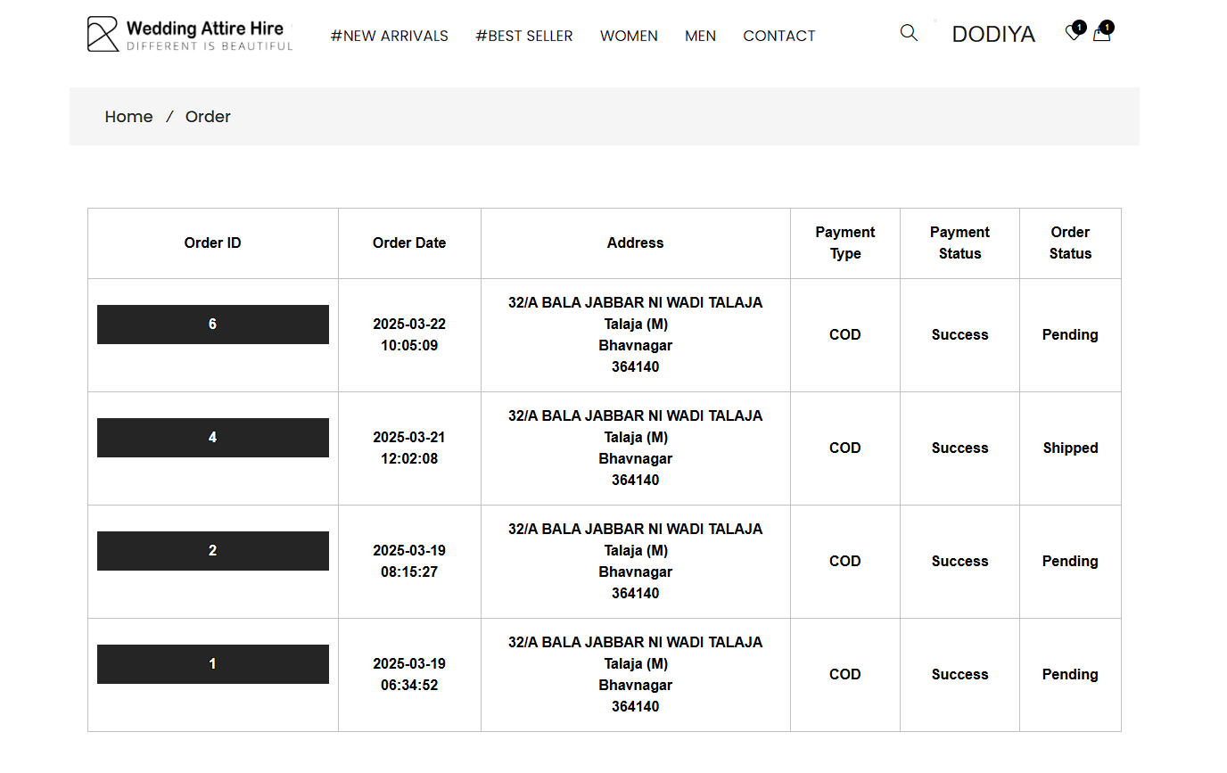

**User Profiles**

* Keep your account updated by editing your personal details. Simply modify your name and click **Update** to save changes.
* Secure your account by updating your password regularly. Enter your **current password**, set a **new password**, confirm it, and click **Update**.

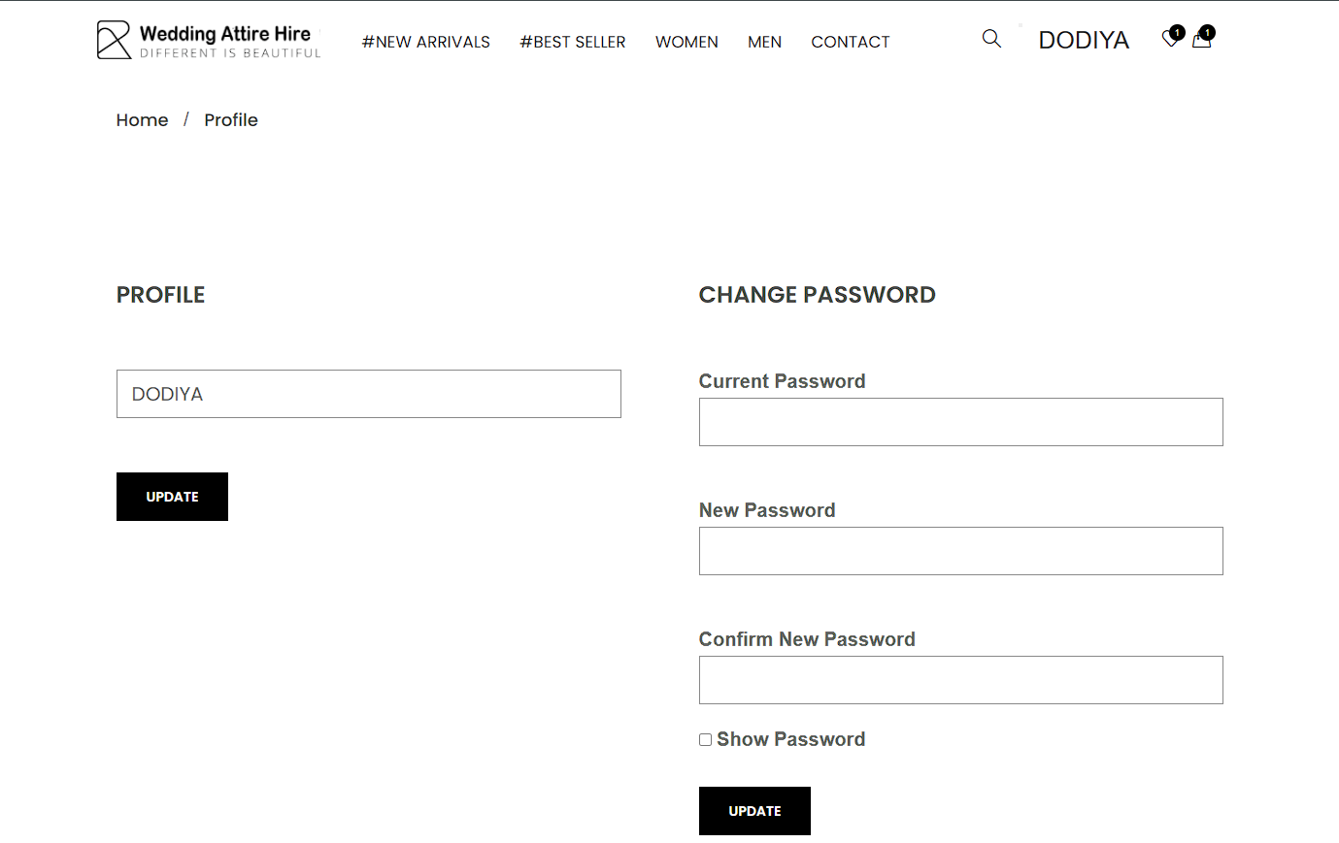

# Chapter- 4 Testing and Implementation

##### TESTING

Software Testing is defined as an activity to check whether the actual results match the expected results and to ensure that the software system is defect free. It involves execution of a software component or system component to evaluate one or more properties of interest.



Software testing also helps to identify errors, gaps or missing requirements in contrary to the actual requirements. It can be either done manually or using automated tools. Some prefer saying Software testing as a White box and Black Box Testing.

##### Test Plan

A test plan is a detailed document that describes the test strategy, objectives, schedule, estimation and deliverables and resources required for testing.



Test Plan helps us determine the effort needed to validate the quality of the application under test. The test plan serves as a blueprint to conduct software testing activities as a defined process which is minutely monitored and controlled by the test manager.

##### Testing Strategies

A software or QA strategy is an outline describing the software development cycle testing

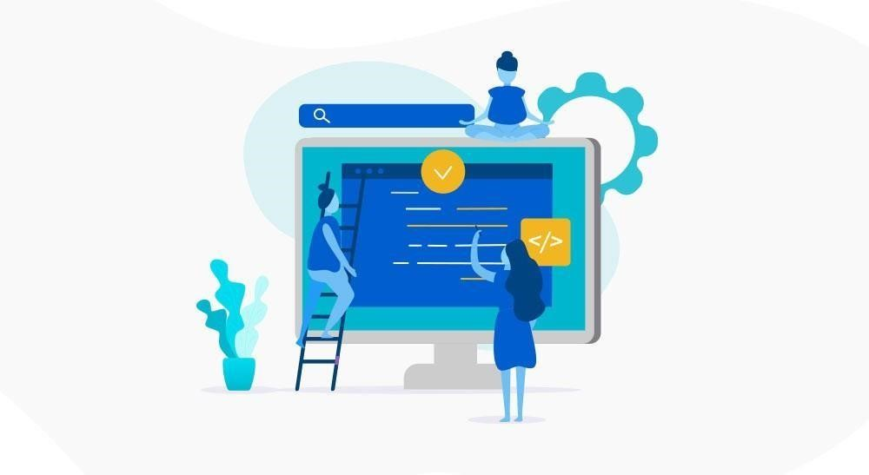

approach. The strategies describe ways of mitigating product risks of stakeholders in the test level, the kind of testing to be performed and which entry and exit criteria would apply.

Software testing or Quality Assurance strategies describe how to mitigate product risks of stakeholders at the test level, which kinds of testing are to be done and which entry and exit criteria will apply. They’re made based on development design documents.

**Types of testing strategies**

Some of the testing methodologies that may be part of an organization’s testing strategy are:

* [Analyticalstrategy](https://tryqa.com/what-is-test-strategy-types-of-strategies-with-examples/#analytical_strategy)
* [Modelbasedstrategy](https://tryqa.com/what-is-test-strategy-types-of-strategies-with-examples/#model_based_strategy)
* [Methodicalstrategy](https://tryqa.com/what-is-test-strategy-types-of-strategies-with-examples/#methodical_strategy)
* [StandardscompliantorProcesscompliantstrategy](https://tryqa.com/what-is-test-strategy-types-of-strategies-with-examples/#standards_or_process_compliant_strategy)
* [Reactivestrategy](https://tryqa.com/what-is-test-strategy-types-of-strategies-with-examples/#reactive_strategy)
* [Consultativestrategy](https://tryqa.com/what-is-test-strategy-types-of-strategies-with-examples/#consultative_strategy)
* **Analytical strategy:**

For example risk based testing or requirements based testing. Here the testing team defines the testing conditions to be covered after analyzing the test basis, be it risks or requirements, etc,

So, in case of testing based on requirements, requirements are analyzed to derive the test conditions. Then tests are designed, implemented and executed to meet those requirements.

Even the results are recorded with respect to requirements, like requirement tested

And passed, those that were tested but failed and those requirements which are not fully tested.

* **Model based strategy:**

In this technique, testing team chooses an existing or expected situation and creates a model for it, taking into account inputs, outputs, processes and possible behavior. The models are also developed according to existing software, hardware, data speeds, infrastructure, etc.

Let us consider the scenario of mobile application testing. To carry out its performance testing, models may be developed to emulate outgoing and incoming traffic on mobile network, number of active/inactive users, projected growth, etc

* **Methodical strategy:**

Here test teams follow a predefined quality standard (like ISO25000), checklists or simply a set of test conditions**.** Standard checklists can exist for specific types of testing (like security), application domains.

For instance, in case of [maintenance testing,](https://tryqa.com/what-is-maintenance-testing/)a checklist describing important functions, their attributes, etc. is sufficient to perform the tests

* **Standards or process compliant strategy:**

Medical systems following US Food and Drugs Administration (FDA) standards are good examples of this technique.

Here the testers follow the processes or guidelines established by committee for **s**tandards or panel of industry experts to identify test conditions, define test cases and put testing team in place.

In the case of a project following [Scrum A](https://tryqa.com/what-are-agile-software-development-approaches-scrum-kanban-xp-explained/)gile technique, testers will create its complete

test strategy, starting from identifying test criteria, defining test cases, executing tests, report status etc. around each [user stories.](https://tryqa.com/what-is-user-story-template-in-agile-software-development/)

* **Reactive strategy:**

Here tests are designed and implemented only after the real software is delivered. So testing is based on defects found in actual system.

Consider a scenario where[exploratory testingi](https://tryqa.com/what-is-exploratory-testing-in-software-testing/)s being used. Test charters are developed based on the existing features and functionalities. These test charters are updated based on the results of the testing by testers. [Exploratory testing can be applied to Agile](https://tryqa.com/what-is-exploratory-testing-in-agile-methodology/) development projects as well.

* **Consultative strategy:**

As the name suggests, this testing technique uses consultations from [key stakeholders](https://tryqa.com/how-to-identify-stakeholders-for-testing/) as input to decide the scope of test conditions as in the case of user directed testing. Let us consider a situation where the [compatibility o](https://tryqa.com/what-is-compatibility-testing-in-software/)f any webbased application with possible browsers is to be tested. Here the application owner would provide a list of browsers and their versions in order of priority.

They may also provide a list of connection types, operating systems, anti malware software, etc. against which they want the application to be tested.

The testers may then use different techniques like testing pair wise or [equivalencepartitioningt](https://tryqa.com/what-is-equivalence-partitioning-in-software-testing/)echniques depending upon priority of the items in the provided lists.

* **Regression averse strategy:**

Here testing strategies focus on [reducing regression risks f](https://tryqa.com/how-to-manage-regression-risk-and-evolve-manual-automated-test-cases-in-agile-methodology/)or functional or nonfunctional product parts.

Continuing our previous example of web application, if the application needs to be [**t**ested forregression issues,](https://tryqa.com/what-is-regression-testing-in-software/)testing team can create test automation for both typical and exceptional use cases.

They can even use GUI based automation tools so that the tests can be run whenever the application is changed.

It is not necessary to use any one of the techniques listed above for any testing project. Depending on product and organization’s requirements, two or more techniques may be combined.

##### Level of Testing

The purpose of Levels of testing is to make software testing structured/efficient and easily find all possible test cases/test scenarios at a particular level. In the SDLC model, there are personalized phases such as requirement meeting, analysis, coding, design, execution, testing, and deployment. These all phases go through the process of levels of testing in software testing.

There are many different testing levels that are used or help to check actions and performance for software testing. These testing levels are designed for missing areas and re-coded and re- linked between the development lifecycle states.

In general, mainly four levels of testing in software testing: Unit Testing, System Testing, Integration Testing, and Acceptance Testing.

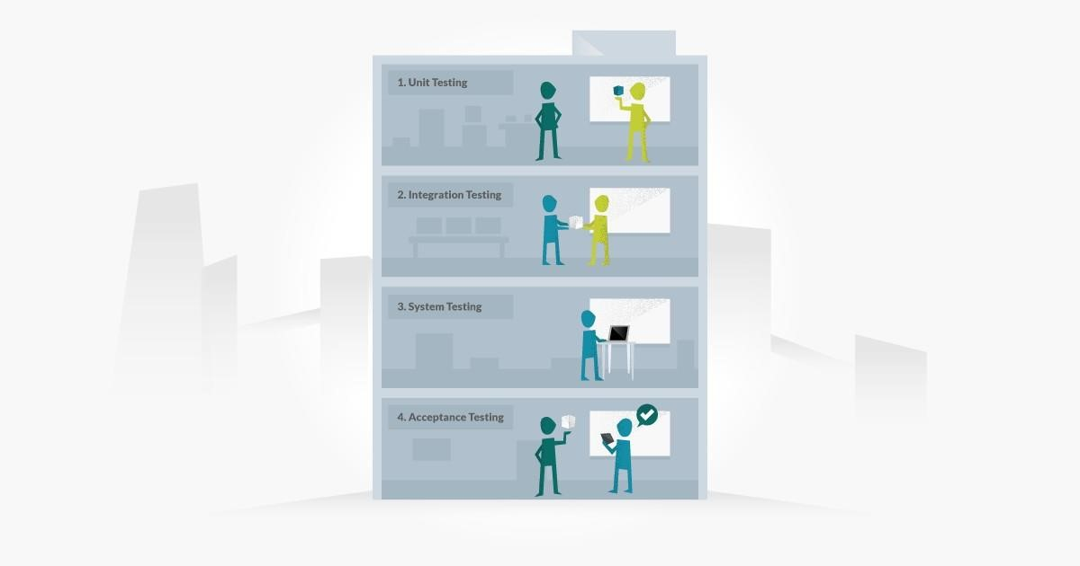

* Unit Testing
* Integration Testing
* System testing
* Acceptance testing

Every testing level is very important testing for software testing but these four levels of testing are very important testing for software engineering.

* **Unit Testing:**

This type of testing used tests for a single component or a single unit in software testing and this kind of testing is performed by the developer.

[Unittestingi](https://qacraft.com/what-is-unit-testing/)s also the first level of functional testing. The primary goal of unit testing is to validate the performance of unit components.

Unit is the smallest testable portion of the system or application and the main aim is to test that each individual component or unit is correct in terms of fulfilling requirements and desired functionality.

Z The main advantagessssssss of this testing is that by detecting any errors in the software early in the day is that by doing so the team reduced software development risks, as well as time and money wasted in having to go back and take back fundamental defects in the program once it is nearly completed.

* **Integration Testing:**

[Integration testing m](https://qacraft.com/what-is-integration-testing/)eans combining different software modules and phases and testing as a group to make sure that the integrated system is ready for system testing or not, and there are many ways to test how different components of the system function at their interface.This type of testing is performed by testers and integration testing finds the data flow from one module to other modules.

* **System Testing:**

System testing is most probably the final test to identify that the system meets the specification and criteria and it evaluates both function and non-functional needs for the testing.

System testing is allowing to check the system’s compliance as per the requirements and all the components of the software are tested as a whole in order to ensure that the overall product meets the requirements specified. It involves load, reliability, performance, and security testing.

System testing is a very important step as the software is almost ready for production in the market and once it is deployed it can be tested in an environment that is very close to the market/user-friendly environment which the user will experience.

* **Acceptance Testing:**

The aim of acceptance testing is to evaluate whether the system complies with the enduser requirements and if it is ready for deployment.

The tester will utilize a different method such as pre-written scenarios and test cases to test the software and use the results obtained from these tools to find ways in which the system can be improved also QA team or testing team can find out how the product will perform when it is installed on the user’s system.

Acceptance testing ranges from easily finding spelling mistakes and cosmetic errors to relatable bugs that could cause a major error in the application.

##### Types of Testing

Software testing is generally classified into two main broad categories: functional testing and non-functional testing. There is also another general type of testing called maintenance testing.

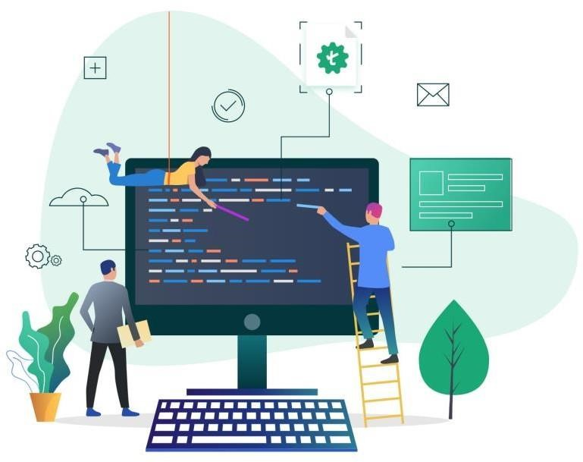

**Functional Testing :**

Functional testing involves the testing of the functional aspects of a software application.

When you’re performing functional tests, you have to test each and every functionality.

You need to see whether you’re getting the desired results or not.

Functional tests are performed both manually and using automation tools. For this kind of testing, manual testing is easy, but you should use tools when necessary

There are several types of functional testing, such as:

* Unit Testing
* Interface Testing
* Smoke Testing
* Integration Testing
* Regression Testing
* Sanity Testing
* System Testing
* User Acceptance Testing

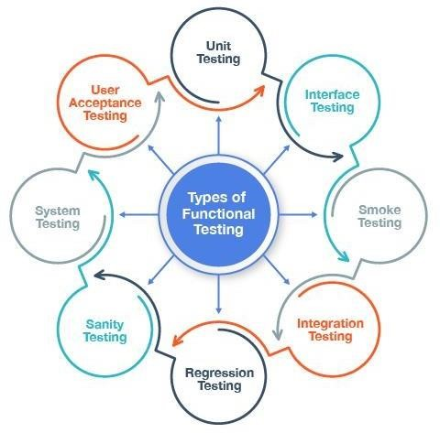

**Unit Testing-** The most basic unit or component of an application is tested usually by the developer to ensure the smallest testable code is working fine. It is a White Box testing technique and appears at the bottom of the V-Model, i.e. it is the first software testing type to be carried out in SDLC.

**Integration Testing-** When two or more components or units of the software are integrated together, they need to interact with each other in the form of commands, data exchange or DB calls. Integration testing is performed on them as a single cluster to check that the interaction between them is happening, as expected.

**Interface Testing-** It comes under Integration testing, the correctness of data exchange or transfer between two components is tested in Interface testing. For e.g. One component creates a .csv file as output, the other connected component processes the .csv file into XML and sends to the third component. During this data transfer, the data should remain intact and all the components should be able to process the file and send the file to the next component successfully.

**System Testing-** All the modules of the application are combined and the whole system is tested as a single unit for correctness against the requirement specification.

**Regression Testing-** Whenever there are some code fixes, or any functionality enhancement, the code is modified. Regression testing makes sure that these code changes have not injected any new defects in the code and that the previously working functionality is also intact and working.

**Smoke Testing-** Performed on initial unstable builds, whenever a new build is released by developers, testing team performs Smoke testing to be sure that all end-to-end functionalities are working. If any of the major functionality is broken due to a new build, the build is rejected and sent again to developers. This is performed to ensure that new code changes have not broken any major functionality and the build can be taken forward for the next level of testing.

**Sanity Testing-** It is normally a subset of Regression tests; it is performed whenever there is a new build released for a stable application. Only after running the Sanity test suite, the build is taken forward for the next level of testing. Difference between Smoke and Sanity is-Smoke testing is performed on an initial unstable application, whereas Sanity is performed on a stable application.

**User Acceptance Testing**- It is the last level of testing in a V-Model, parallel to the requirement analysis phase. It defines how well the application is accepted by the real end- users. The fulfilment of business requirements, by actual users, is checked, in a real environment.

##### Testing Methods

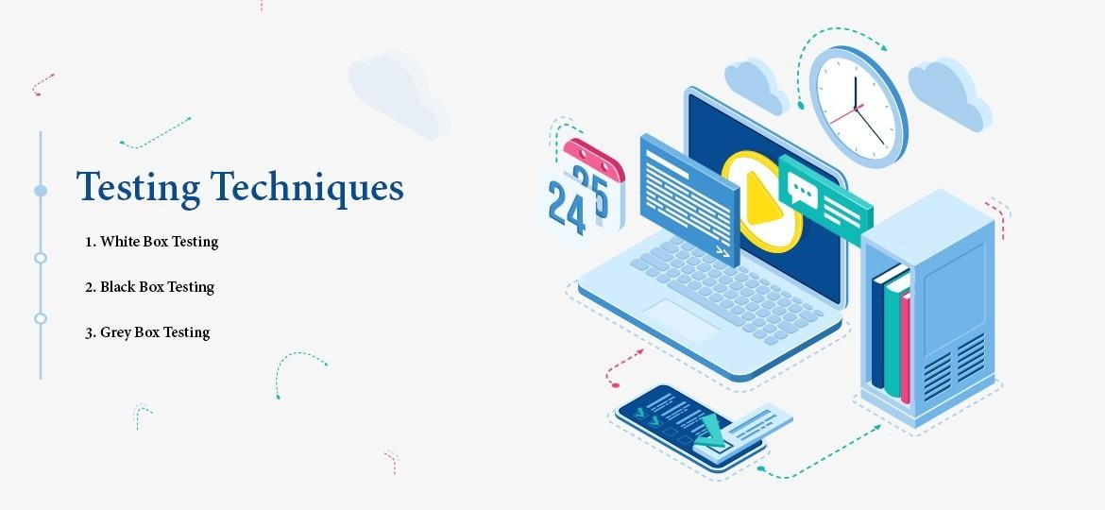

* Black Box
* White Box

❖ Gray Box

**What is Black Box Testing**

Black box testing involves testing a system with no prior knowledge of its internal workings. A tester provides an input, and observes the output generated by the system under test. This makes it possible to identify how the system responds to expected and unexpected user actions, its response time, usability issues and reliability issues.

Black box testing is a powerful testing technique because it exercises a system end-to-end. Just like end-users “don’t care” how a system is coded or architected, and expect to receive an appropriate response to their requests, a tester can simulate user activity and see if the system delivers on its promises. Along the way, a black box test evaluates all relevant subsystems, including UI/UX, web server or application server, database, dependencies, and integrated systems. An example of a [security technology that performs black box testing is Dynamic](https://www.imperva.com/learn/data-security/information-security-infosec/) [ApplicationSecurity Testing (](https://www.imperva.com/learn/application-security/application-security/)DAST), which tests products in staging or production and provides feedback on compliance and security issues.

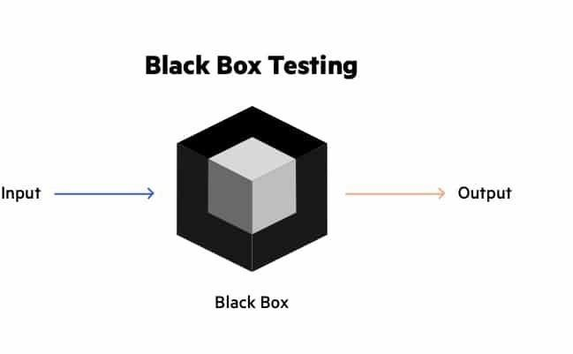

**What is White Box Testing:**

White box testing is an approach that allows testers to inspect and verify the inner workings of a software system—its code, infrastructure, and integrations with external systems. White box testing is an essential part of automated build processes in a modern Continuous Integration/Continuous Delivery (CI/CD) development pipeline.

White box testing is often referenced in the context of Static Application Security Testing (SAST), an approach that checks source code or binaries automatically and provides feedback on bugs and possible vulnerabilities.

White box testing provides inputs and examines outputs, considering the inner workings of the code

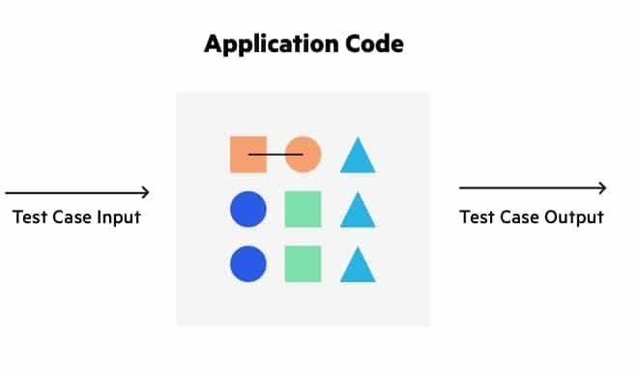

**What is Grey Box Testing:**

Grey box testing (a. k. a grey box testing) is a method you can use to debug software and evaluate vulnerabilities. In this method, the tester has limited knowledge of the workings of the component being tested. This is in contrast to black box testing, where the tester has no internal knowledge, and white box testing, where the tester has full internal knowledge.

You can implement grey box testing as a form of penetration testing that is unbiased and non- obtrusive. In these tests, the tester typically knows what the internal components of an application are but not how those components interact. This ensures that testing reflects the experiences of potential attackers and users.

Grey box testing is most effective for evaluating web applications, integration testing, distributed environments, business domain testing, and performing security assessments. When performing this testing, you should create clear distinctions between testers and developers to ensure test results aren’t biased by internal knowledge.

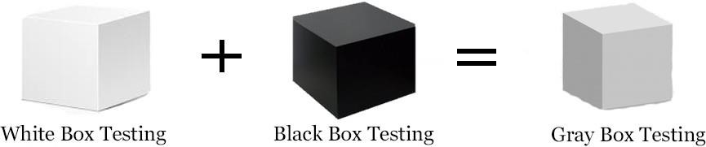

##### TEST CASE

In the simplest form, a test case is a set of conditions or variables under which a tester determines whether the software satisfies requirements and functions properly.

A test case is a single executable test which a tester carries out. It guides them through the steps of the test.

You can think of a test case as a set of step-by-step instructions to verify something behaves as it is required to behave.



A test case usually contains:

* Title
* Description
* Input Data
* Expected Result
* Actual Result (once tested)
* Status
* **Admin Side:**

**Test Case – 1**

|  |  |
| --- | --- |
| **Test Case No:** | 1 |
| **Title** | Login Verification |
| **Description** | This test case allow the admin to access the system. |
| **Input Data** | Enter valid Username and Password |
| **Expected Result** | This test case will check the Admin Username and  Password and then from the Admin table in MySQL database  Case 1 - If Admin Username and Password is entered and it’s match, then it will open admin side page.  Case 2 – If Admin Username and Password is entered and doesn’t match, then it will show error message “Please Enter Correct Login Details”. |
| **Actual Output** | System work properly |
| **Status** | Pass. |

**Test Case 2**

|  |  |
| --- | --- |
| **Test Case No:** | 2 |
| **Title** | Product Master |
| **Description** | This test case allow to add product description in add product. |
| **Input Data** | Enter product description |
| **Expected Result** | This test case will allow to check whether the Admin or Vendor have entered correct details or not in Product Master.  Case 1- In Product Master Admin or Vendor have entered the correct details of product, then it will allow us to submit it.  Case 2 - In Product Master Admin or Vendor does not have entered the details completely, then it will show error message “Please fill out this field”. |
| **Actual Result** | System allowed to insert product information |
| **Status** | Pass. |

**Test Case - 3**

|  |  |
| --- | --- |
| **Test Case No:** | 3 |
| **Title** | Categories Master |
| **Description** | This test case allow to add categories name in add categories |
| **Expected Result** | This test case will allow to check whether the admin has entered categories name or not in Categories Master.  Case 1- In Categories Master Admin has entered the categories name of product, then it will allow us to submit it.  Case 2 - In Categories Master Admin does not has entered the categories name, then it will show error message “Please fill out this field”. |
| **Actual Result** | System allowed to insert categories name. |
| **Status** | Pass. |

**Test Case - 4**

|  |  |
| --- | --- |
| **Test Case No :** | 4 |
| **Title** | Sub Categories Master |
| **Description** | This test case allow to add sub categories detail in add Sub Categories |
| **Input Data** | Enter sub categories detail. |
| **Expected Result** | This test case will allow to check whether the admin has entered categories name or not in Sub Categories master.  Case 1- In Sub Categories Master Admin has entered the sub categories detail of product, then it will allow us to submit it.  Case 2 - In Sub Categories Master Admin does not has entered the categories and sub categories of product, then it will show error message“Please fill out this field”. |
| **Actual Result** | System allowed to insert Sub Categories detail. |
| **Status** | Pass. |

**Test Case – 5**

|  |  |
| --- | --- |
| **Test Case No :** | 5 |
| **Title** | Login Verification of vendor |
| **Description** | This test case allow the vendor to access the system. |
| **Input Data** | Enter valid User Name and Password |
| **Expected Result** | This test case will check the vendor Username and  Password and then from the vendor table in MYSQL database.  Case 1 - If Vendor Username and Password is entered and it’s match, then it will open Admin side page.  Case 2 - If Vendor Username and Password is entered and doesn’t match,  then it will show error message “Please Enter Correct Login Details”. |
| **Actual Output** | System work properly |
| **Status** | Pass. |

❖**User Side:**

**Test Case – 1**

|  |  |
| --- | --- |
| **Test Case No :** | 1 |
| **Title** | Login Verification |
| **Description** | This test case allow the User to access the system. |
| **Input Data** | Enter valid Email and Password |
| **Expected Result** | This test case will check the User Email and  Password and then from the User table in MYSQL database.  Case 1 - If User Email and Password is entered and it is correct, then it will login.  Case 2 -If User Email and Password is entered and it is incorrect, then it will show error message “Please Enter Valid  Login Detail”.  Case 3 - If User Email does not entered, then it will show error message “Please Enter email”.  Case 4 - If User Password does not entered, then it will show error message “Please Enter password”. |
| **Actual Output** | System work properly |
| **Status** | Pass. |

**Test Case – 2**

|  |  |
| --- | --- |
| **Test Case No :** | 2 |
| **Title** | Register |
| **Description** | This test case allow to register user. |
| **Input Data** | Enter user registration detail. |
| **Expected Result** | This test case will allow to register the user and it will check whether the user has entered correct details or not.  Case 1- in registration if user has entered correct details, then it will allow us to register.  Case 2 - In registration if user does not has entered correct details, then it will not allow us to register.  Case 3 - If User has entered Email which already exist in database then it will show error message ”Email id already exists”.  Case 4 – If User has entered Mobile number which already exist in database then it will show error message ”Mobile number already exists”. |
| **Actual Result** | System allowed user registration |
| **Status** | Pass. |

**Test Case - 3**

|  |  |
| --- | --- |
| **Test Case No :** | 3 |
| **Title** | Forgot Password |
| **Description** | This test case allow us to change password |
| **Input Data** | Enter Email id. |
| **Expected Result** | This test case will allow us to change a password.  Case 1- In forgot Password if Email id not correct, then it will show error message “Email id not registered with us”. |
| **Actual Result** | System allowed to change password. |
| **Status** | Pass. |

**Test case – 4**

|  |  |
| --- | --- |
| **Test Case No :** | 4 |
| **Title** | Coupon Master |
| **Description** | This test case allow us to add coupon. |
| **Input Data** | Enter Coupon. |
| **Expected Result** | This test case will allow us to add Coupon.  Case 1- If Admin has decided minimum value to apply coupon, so when user purchase the product of that value or  above that value, the user will be allowed to apply coupon.  Case 2- If Admin has decided minimum value to apply coupon, so when user purchase the product of less than that value, the user will not be allowed to apply coupon. |
| **Actual Result** | System allowed to add coupon. |
| **Status** | Pass. |

**Test Case - 5**

|  |  |
| --- | --- |
| **Test Case No :** | 5 |
| **Title** | Contact us |
| **Description** | This test case allow to send query message to the admin |
| **Input Data** | Enter Contact details. |
| **Expected Result** | This test case will allow us to contact user to admin.  Case 1 - If user does not fill full information in contact page then it will show error message “Please fill the information”. |
| **Actual Result** | System allowed to send Message “Thank You”. |
| **Status** | Pass. |

# Chapter- 5 Conclusion

##### LIMITATION OF SYSTEM

While the online wedding attire rental system offers numerous benefits, it also has certain limitations:

* **Single Product Rental** – A user can rent only one outfit at a time, limiting the flexibility for those who may need multiple outfits for different events.
* **Delivery Delays** – Despite efforts to ensure timely delivery, unexpected delays can occur.
* **Limited Trial Options** – Customers cannot physically try on outfits before renting, which may lead to sizing issues.
* **Return and Damage Policies** – Strict policies on damages or late returns may pose challenges for some customers.ss
* **Availability Constraints** – Popular outfits may be booked in advance, limiting last-minute rental options.
* **Internet Dependency** – Users must have an internet connection to browse and rent outfits.

##### FUTURE SCOPE OF APPLICATION

The application has significant potential for future enhancements, including:

**Software Scope:**

* **Extensibility:** The system can be expanded to introduce new features, such as virtual try-on options or personalized recommendations.
* **Reusability:** The code can be updated for future versions, improving performance and adding more functionalities.
* **Understandability:** A clean and structured codebase ensures easy maintenance and future modifications.
* **Cost-effectiveness:** The system is designed to be developed within a budget while meeting all essential requirements.

##### BIBLIOGRAPHY

**Learning Resources for Web Development:**

* [W3Schools](https://www.w3schools.com) – PHP, HTML, JavaScript, CSS
* [Bootstrap Framework](https://getbootstrap.com) – UI Development
* TutorialsPoint – SQL Database Management

**YouTube Learning Channels:**

* **Yahoo Babas**
* **Programming with Vishal**

This system sets the foundation for a user-friendly and efficient wedding attire rental platform, with scope for future improvements to enhance the customer experience.